**FORM A1**

# **STUDENT PLAGIARISM DISCLAIMER FORM**



PLAGIARISM DISCLAIMER

STUDENT NAME:

STUDENT NUMBER:

PROGRAMME:

YEAR:

MODULE:

LECTURER:

ASSIGNMENT TITLE:

DUE DATE:

DATE SUBMITTED:

ADDITIONAL INFORMATION:

I understand that plagiarism is a serious academic offence, and that AIT deals with it according to the AIT Policy on Plagiarism.

I have read and understand the AIT Policy on Plagiarism and I agree to the requirements set out therein in relation to plagiarism and referencing. I confirm that I have referenced and acknowledged properly all sources used in preparation of this assignment. I understand that if I plagiarise, or if I assist others in doing so, that I will be subject to investigation as outlined in the AIT Policy on Plagiarism.

I understand and agree that plagiarism detection software may be used on my assignment. I declare that, except where appropriately referenced, this assignment is entirely my own work based on my personal study/or research. I further declare that I have not engaged the services of another to either assist in, or complete this assignment.

Signed:

**Dated:**

Table of Contents

Student Plagiarism Disclaimer Form 1

Getting To Know New People 3

Sharing Learning Resources 4

Giving And Receiving Feedback 5

Public Speaking As Part Of A Group 6

# Getting to Know New People

As a class we participated in many bonding and icebreaking activities. One of the icebreaker activities was we had to organise ourselves into different sorting, such as in alphabetical order, in age, etc. After each sorting, the lecturer would pick one student to review the line by stepping out. Another activity was that we were split into groups and had to find out specific facts and common interest about each other. After this we had to give a short presentation informing the class about a person in our group.

I felt calm as the whole class participated intuitively in each activity. The activities allowed me to introduce myself formally, interact with my classmates and learn new and unique things about them.

This activity was reminiscent of how I got to know my football teammates. We had to split into groups and tell each member about our background. Activities like this reduces tension and fear in the group.

The activity went very well. The class participated fully in the activity. The class talked together and helped each other out.

This activity helped me to understand how to introduce myself formally to new people. I believe that this is very important in life as making relationships helps to reduce tension in a working environment. It will also help me in the future when I start working, as I need to be able to socialise with my future work colleagues.

Figure 1: This screenshot shows another activity we took part in to get to know each other. We had to make a post on Moodle describing ourselves so that we could learn more about each other.

# Sharing Learning Resources

We had to upload and comment on a secondary source on Moodle. We then had to give feedback to one of our classmates on their secondary source. We did this so that we could practice referencing sources.

I felt very intrigued to see the other classmates’ secondary sources and to see the feedback received.

This activity reminded me of class assignments I had to do in second level education. In these we were told to reference our material as well.

The activity went well. Everyone posted their secondary sources and we were given the opportunity to respond and give feedback to others. As a result, we were able to learn from each other’s mistakes. This improved our ability to reference secondary sources, give good feedback and constructive criticism.

In the future I will be sure to use these skills that I have learned and apply them to similar tasks. I will need to do this as in the future I will be writing reports whereby I will need to reference other material. Thanks to this activity I now know that my referencing must be in a certain format for it to be legible.

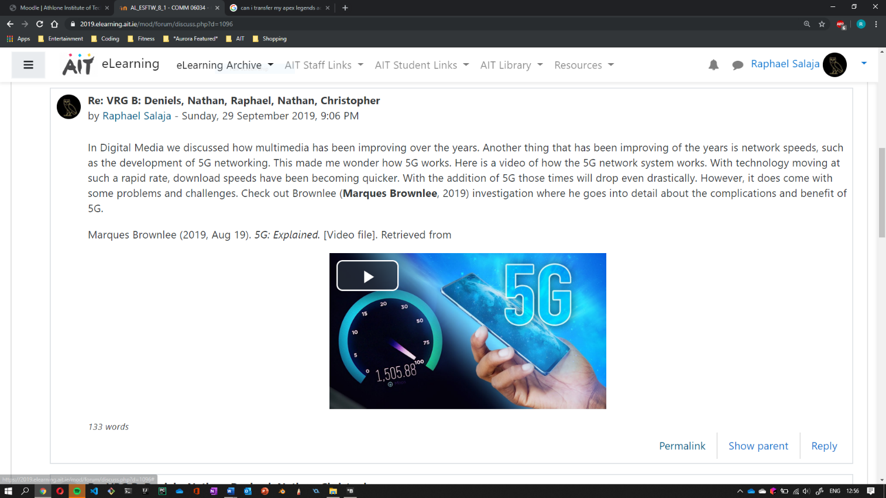

Figure 2: This screenshot shows the secondary source that I posted on Moodle. As you can see, I implemented proper formatting and referencing in my post.

Giving and Receiving Feedback

We had to give feedback to one of our classmates on their secondary source. We did this so that we could practice how to give good feedback.

I felt very eager to see my other classmates’ feedback on my secondary sources.

This activity reminded me of my time playing sports. Sometimes we watched recordings of our matches, then we gave feedback on other teammates’ decisions and actions. This allowed us to improve and get better as a team.

The activity went well. We were able to give feedback on our classmate’s secondary sources. The activity allowed us to gain a deeper understanding of how to reference better as we learned from each other’s mistakes.

In the future I will be able to apply these skills that I have learned to similar tasks. I will need to do this because in the future I will be working in groups for various assignments. As a result, I will need to know how to give and receive feedback so that the team can work in one accord.

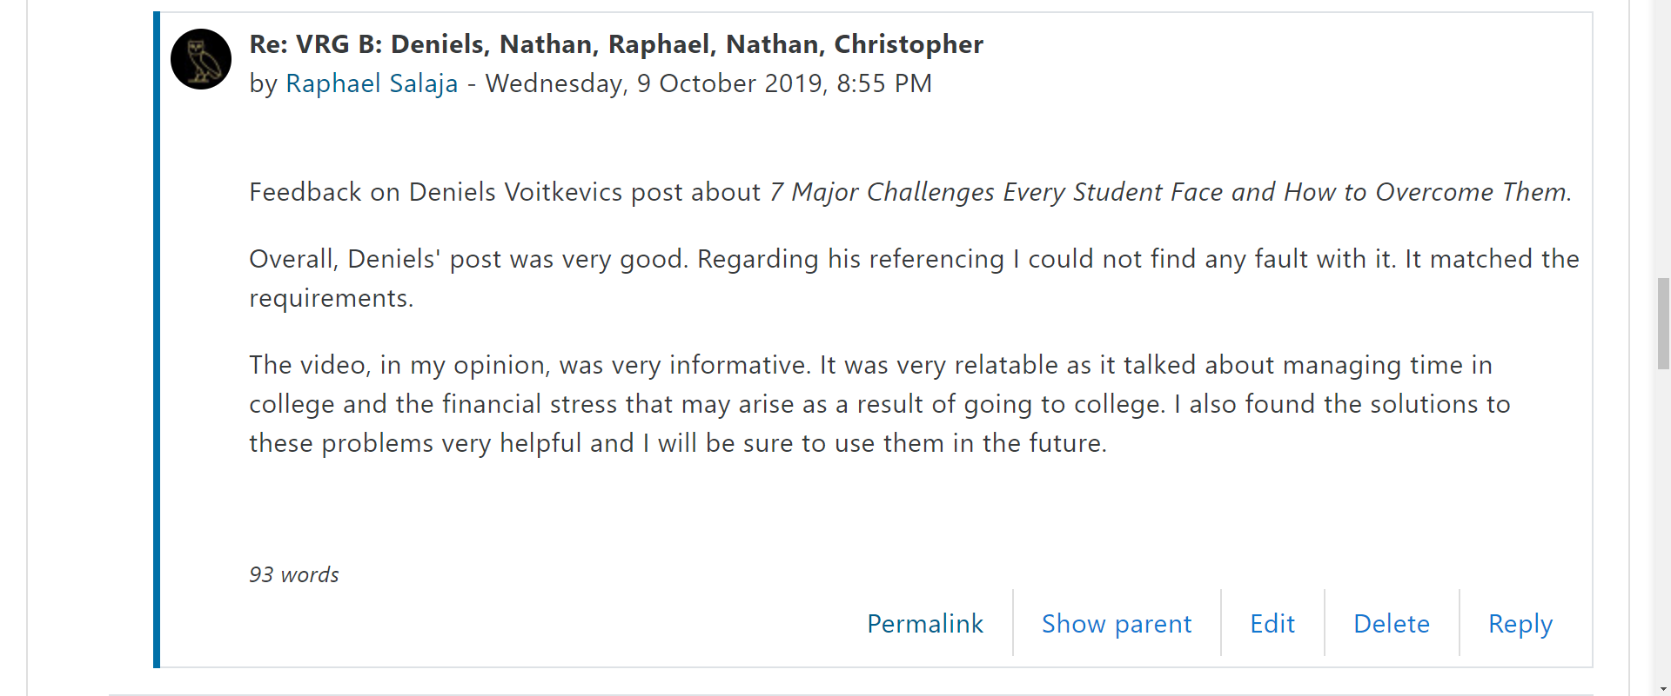

Figure : This screenshot shows the secondary source that I gave feedback to on Moodle.

# Public Speaking as Part of a Group

We had to structure a presentation. We were given some strips of paper with small pieces of information about a holiday. We had to present it in front of the class using specific presentation techniques that we learned.

I felt very calm because I am used to talking in front of crowds.

This activity can be related to me reading at mass for almost four years. Doing this has given me the confidence to be able to talk in front of peers and others.

The activity went rather well. However, as a class we found it difficult to hand over topics to the next person.

In the future I will be sure to apply what I learned as I will have to present assignments and projects during my time in college. For example, before, I used to struggle with constructing a valid introduction, but I have now learned new techniques such as how to construct a well-structured presentation. I learned how to engage my audience from the beginning by grabbing their attention and I learned how to calm the audience at the start of a presentation, by using fillers, such as talking about the weather.

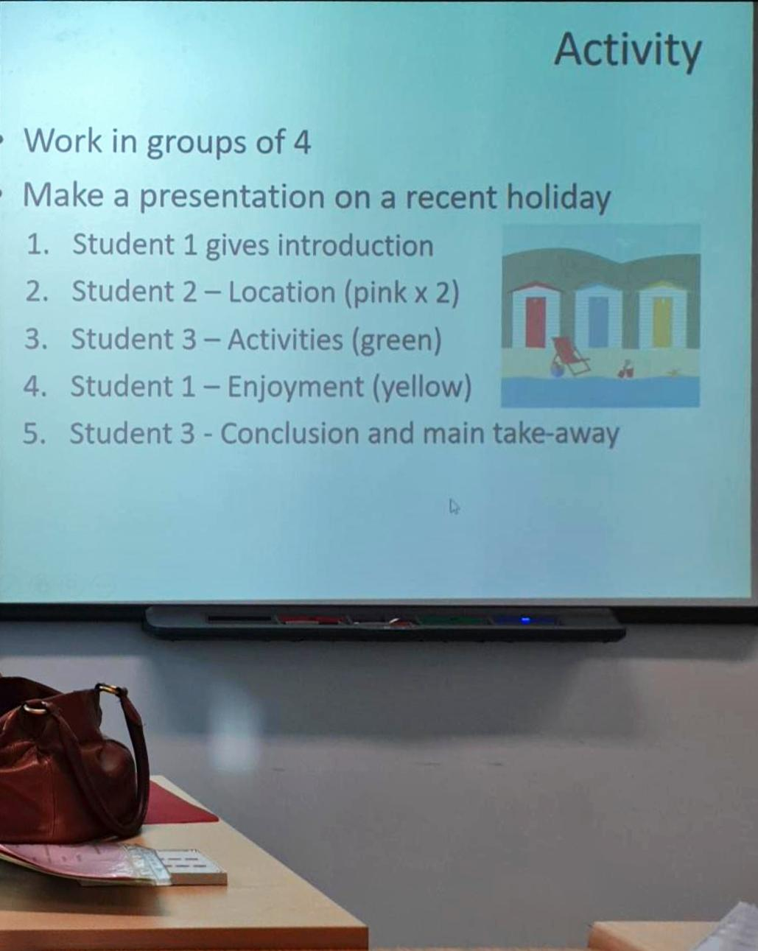

Figure 4: This picture shows the type of guidelines we had to follow while making our presentation.